
Introduction to DOSBox
Lab 3

Computer Organization and Assembly Language

Student Name | Muhammad Hassan Khalid
Registration # | 21L-5692
Instructor | Hazoor Ahmad
Class | CS3
Section | A1, A2, D1, D2
Semester | Fall 2022

Fast School of Computing
FAST-NU, Lahore, Pakistan

Activity 1

Assembly Language Code
[org 0x0100]
mov ax, 0x1254
mov bx, 0x0FFF
add ax, 0xEDAB
add ax, bx
add bx, 0xF001
mov ax,0x4c00
int 0x21

 | ZF | CF | SF | OF

mov ax, 0x1254 | 0 | 0 | 0 | 0
mov bx, 0x0FFF | 0 | 0 | 0 | 0
add ax, 0xEDAB | 0 | 0 | 1 | 0
add ax, bx | 0 | 1 | 0 | 0
add bx, 0xF001 | 1 | 1 | 0 | 0

Debugging Screenshots
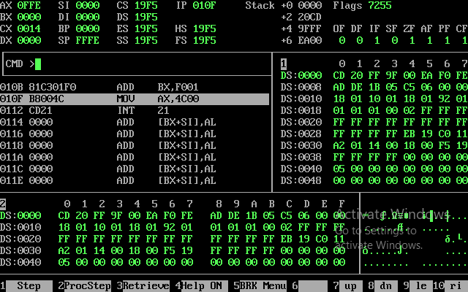

Activity 2

Assembly Language Code
[org 0x0100]

jmp start

multiplicand: dw 13
multiplier : dw 13

result: dw 0

start: mov cx,8
mov bx,[multiplicand]
mov dx,[multiplier]

checkbit: shr dx,1
jnc skip

add [result],bx

skip: shl bx,1
dec cx
jnz checkbit

mov ax, [result]

mov ax,0x4c00
int 0x21

Debugging Screenshots
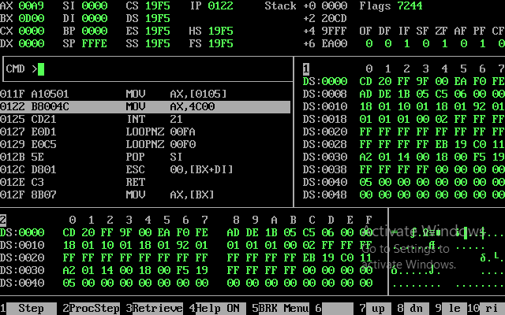

Activity 3

Assembly Language Code
[org 0x0100]

mov si,0
mov cx, 22
mov ax,8
mov bx,0

l1: cmp ax,[array+si]
jz addresult
add si,2
dec cx
jnz l1
jz end

addresult: add bx,1
add si,2
dec cx
jnz l1
jz end

end: mov ax,0x4c00
int 0x21

array : dw 1,9,9,9,8,8,8,8,8,8,1,1,9,9,8,8,8,8,1,9,8,8

Debugging Screenshots

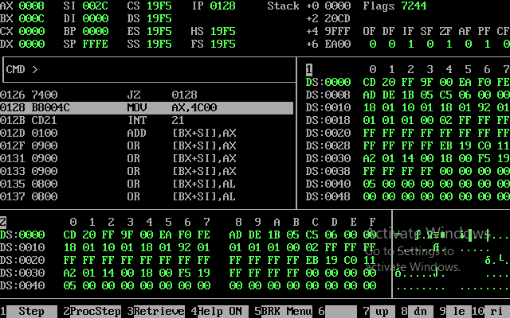

Activity 4

Assembly Language Code
[org 0x0100]

jmp start

memory: dw 4

result: dw 0

start:
mov di,1
mov bx,[memory]

l1:
mov cx,8

mov dx,[memory]

sub dx,di

checkbit: shr dx,1
jnc skip

add [result],bx

skip: shl bx,1
dec cx
jnz checkbit

mov bx, [result]
inc di

cmp di,3
jnz l1

mov ax, [result]

mov ax,0x4c00
int 0x21

Debugging Screenshots
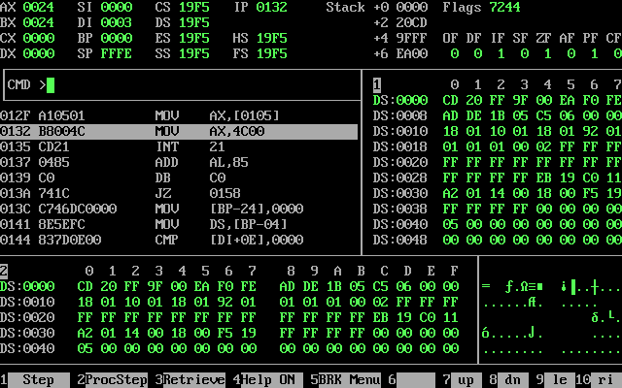

Activity 5

Assembly Language Code
[org 0x0100]

mov ax,[array]
mov bx,0
mov cx,[array+bx]

loop1:
add bx,2
cmp bx ,22
je last
cmp cx,[array+bx]
jb largest
jmp loop1

largest:
mov cx,[array+bx]
jmp loop1

last:
mov ax,0x4c00
int 0x21

array: dw 111,999,888,888,11,99,88,88,1,9,8,8

Debugging Screenshots
